**PROGRAM-1**

**AIM-Write a program for linear search**

#include<iostream>

 using namespace std;

 int main()

{

int a[20],n,x,i,flag=0;

cout<<"How many elements?";

cin>>n;

cout<<"\nEnter elements of the array\n";

for(i=0;i<n;++i)

cin>>a[i];

cout<<"\nEnter element to search:";

cin>>x;

for(i=0;i<n;++i)

{

if(a[i]==x)

{

flag=1;

break;

}

}

if(flag)

cout<<"\nElement is found at position "<<i+1;

else

cout<<"\nElement not found";

return 0;

}

**OUTPUT-**

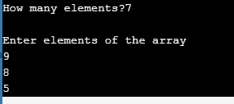

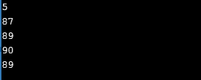

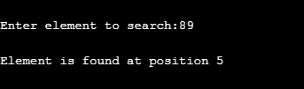

**BINARY SEARCH**